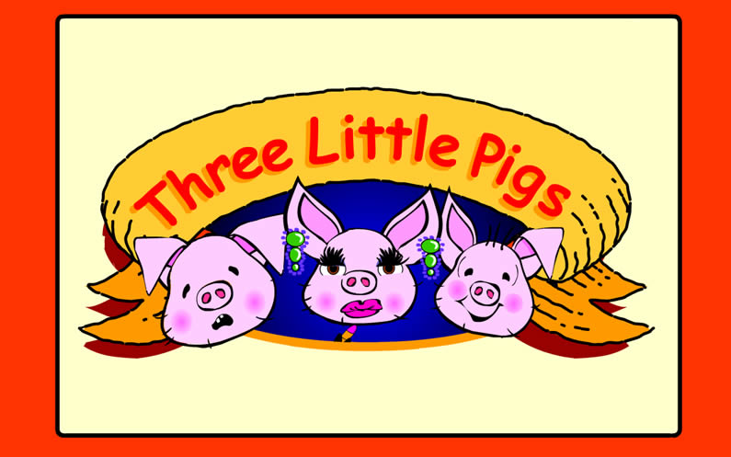

Story retold, designed and animated
by Sheila Cartwright

The Tale of the
© Copyright Northumberland County Council
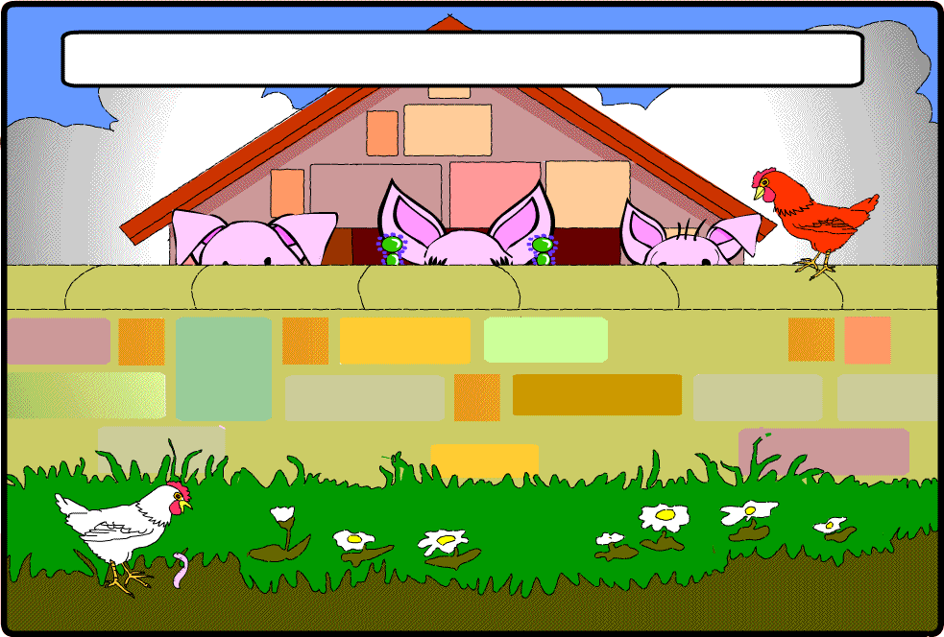
ONE

Once upon a time, there were three little pigs.

TWOO

THREEE

They lived in a pig sty on a farm.

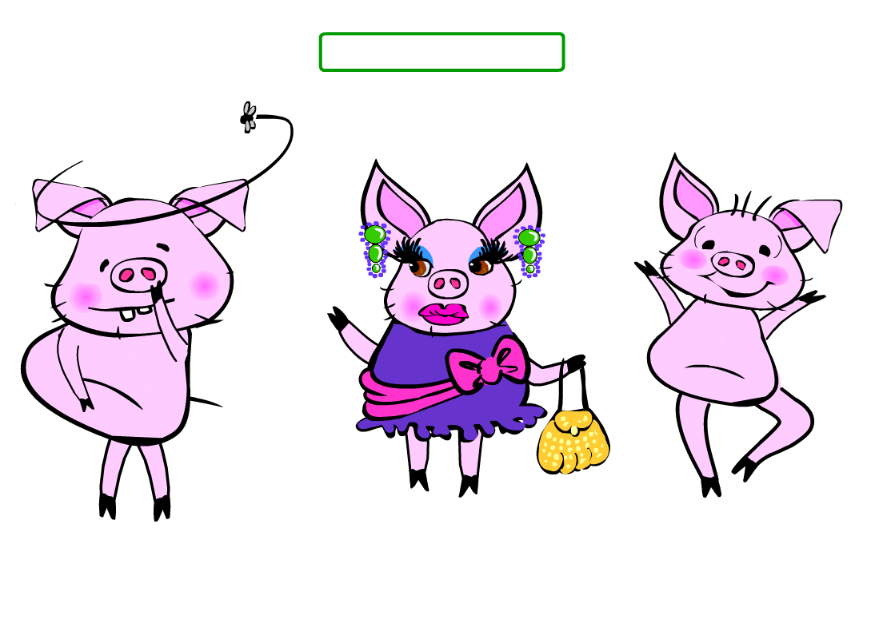
Their names were:
Lazy Pig
Glam Pig
Silly Pig

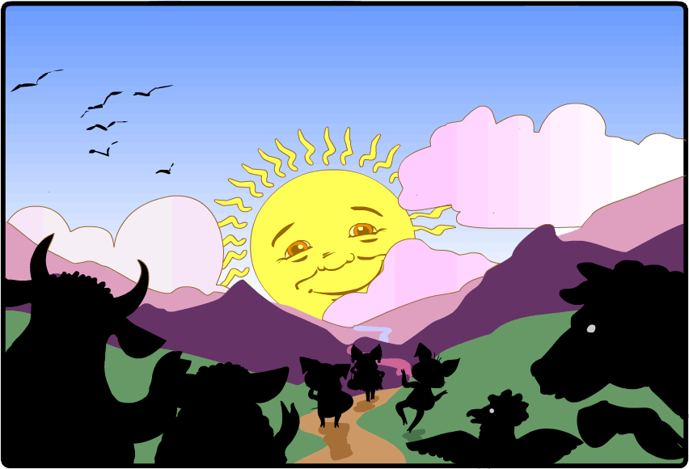
Early one morning, they left their farm to build their own houses.

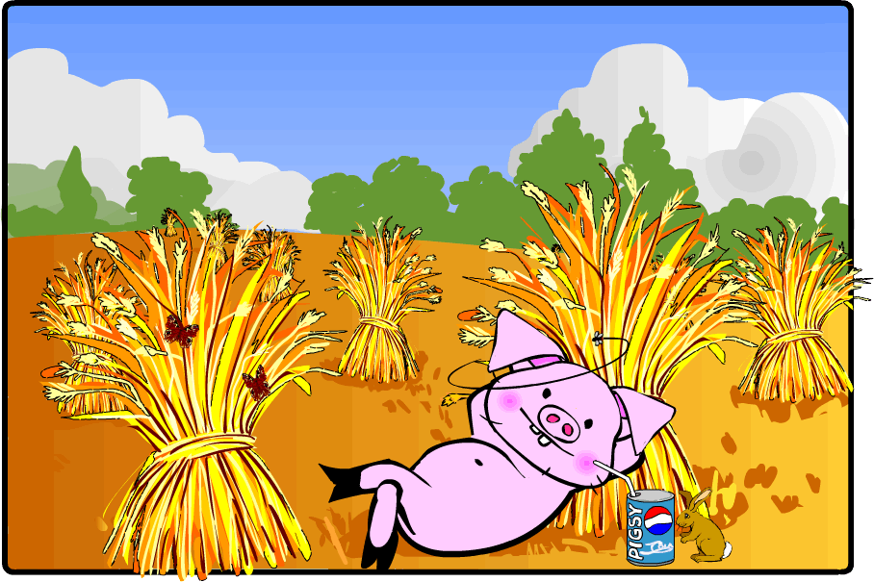
"It will be easy to build a house with straw," thought Lazy Pig.

So he built his house with straw.

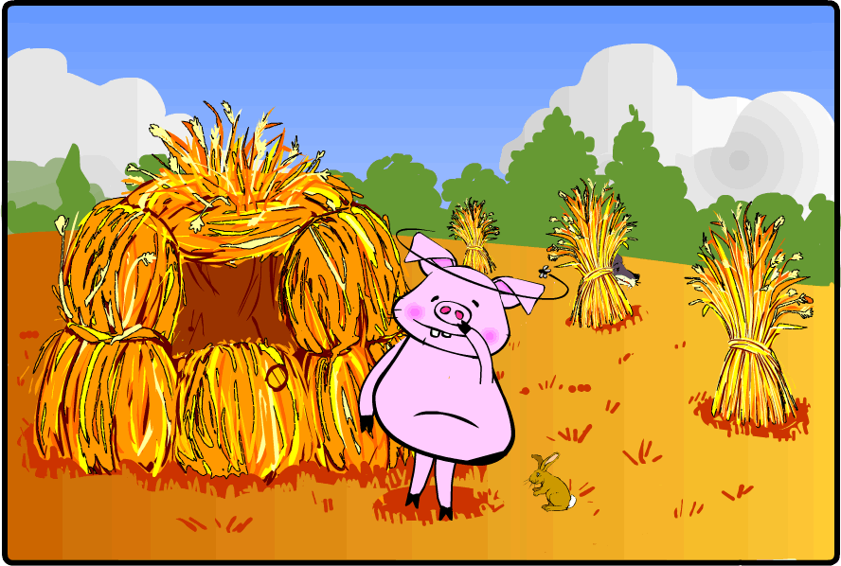

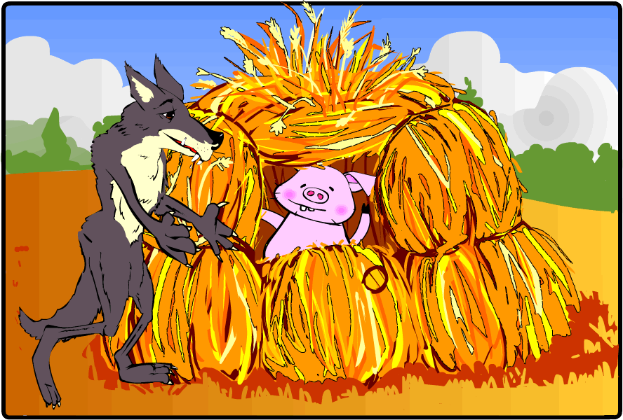

Along came a Big Bad Wolf.
He knocked on the door and said, "Little Pig, Little Pig, let me come in."

"Not by the hair on my chinny chin chin," replied Lazy Pig.

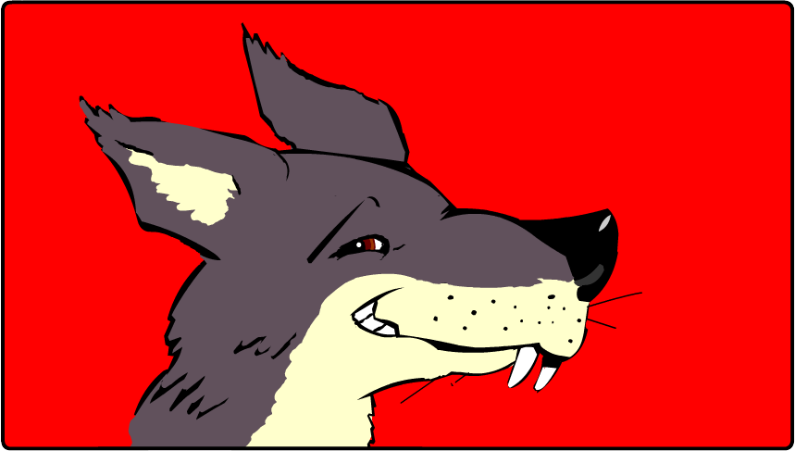
“Then I’ll huff and I’ll puff and I’ll blow your house down!”
said the Big Bad Wolf.

So the Wolf huffed and puffed and he blew the house down.

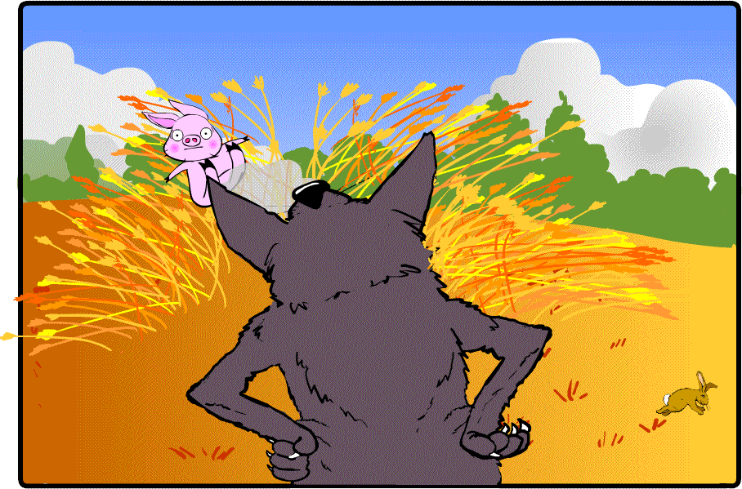

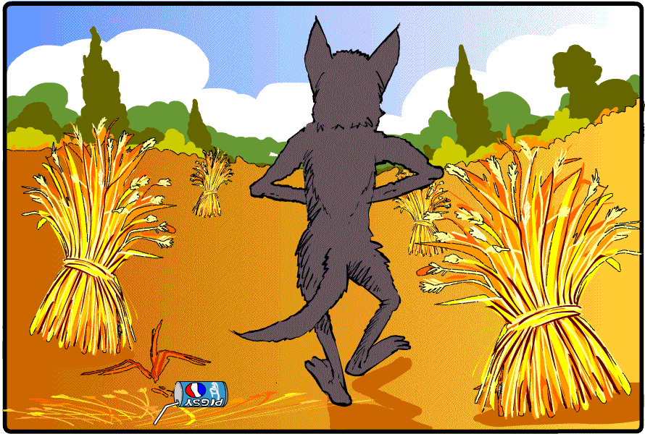
And he ate Lazy Pig!

"Twigs would be good to build a house with,"
thought Glam Pig. "They don't seem very messy."
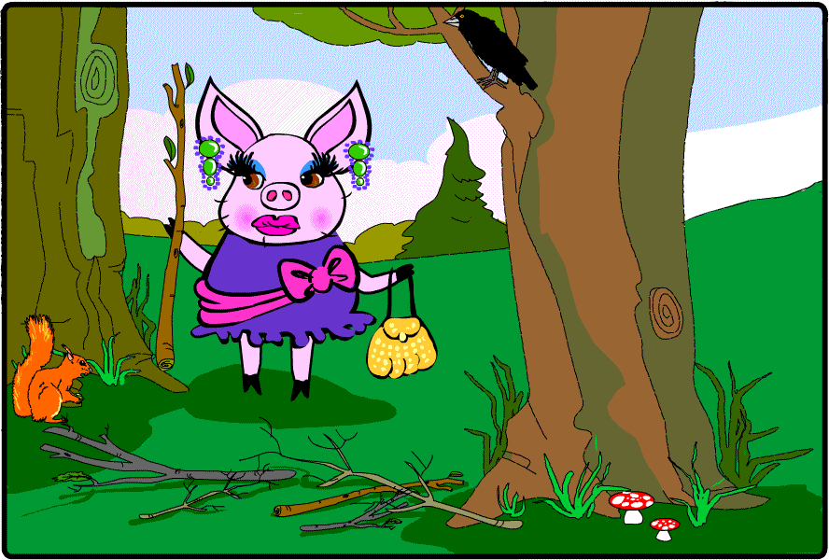

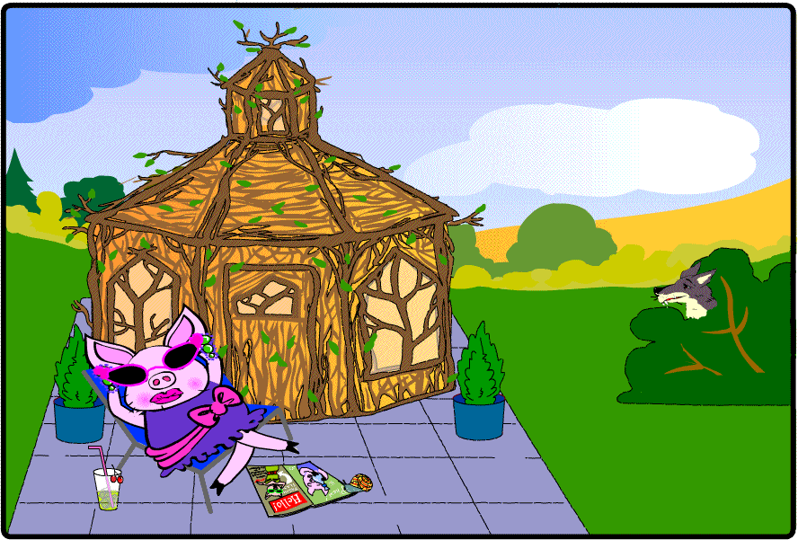
Glam Pig hired an architect and a team of builders and built a house of twigs.

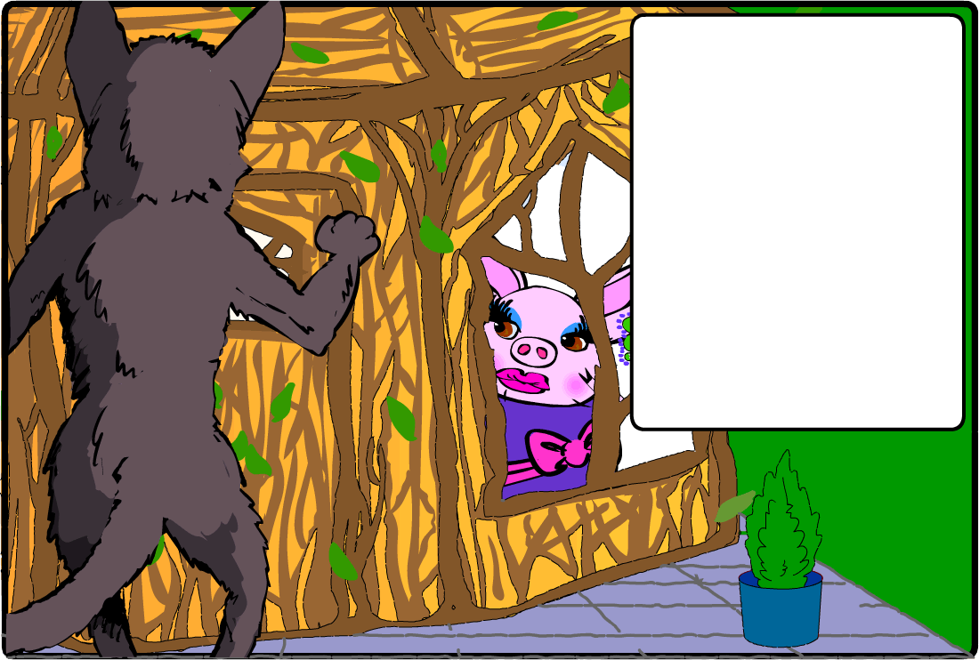
Along came the Big Bad Wolf and he knocked on the door.

"Little Pig, Little Pig, let me come in," he said.

"Not by the hair on my chinny chin chin," said Glam Pig.

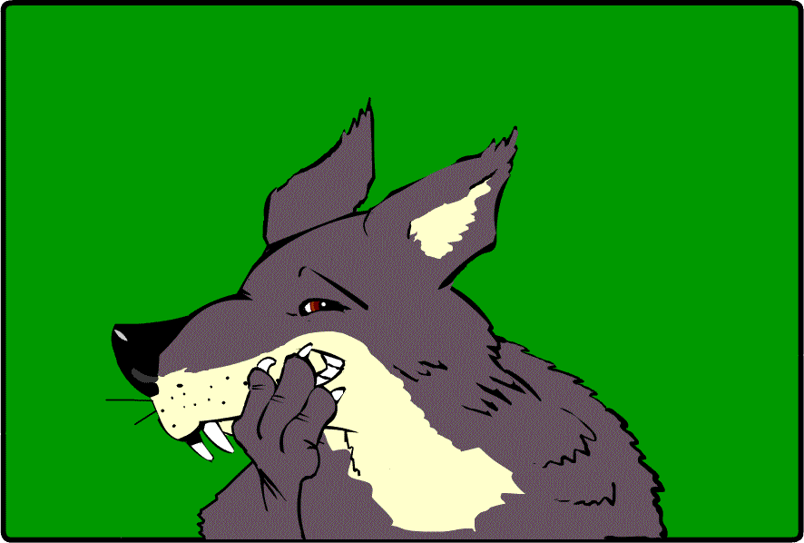
"Then I'll huff and I'll puff and I'll blow your house down!" growled the Big Bad Wolf.

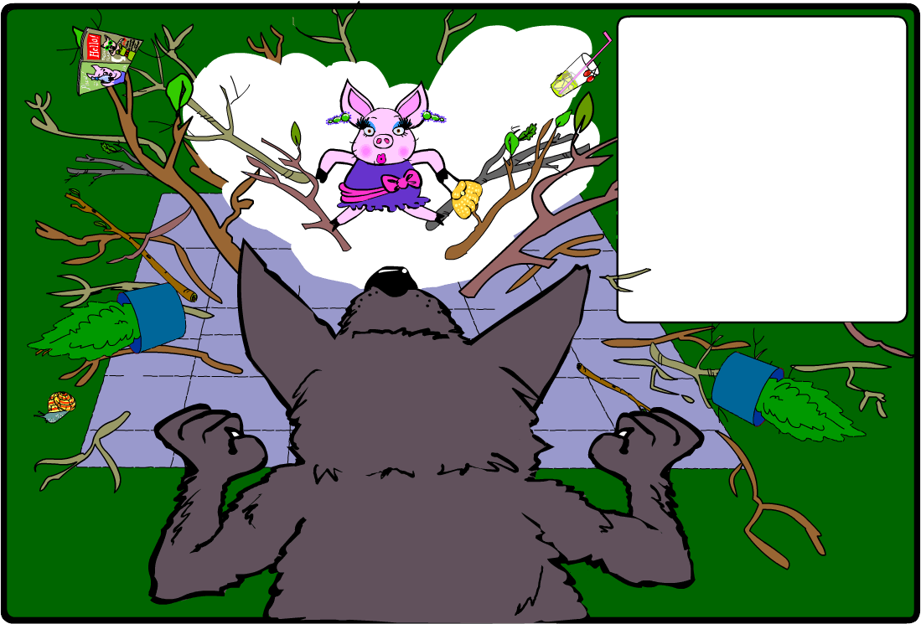
The Big Bad Wolf huffed and puffed and huffed and puffed and he blew the house down.

..And he ate Glam Pig!

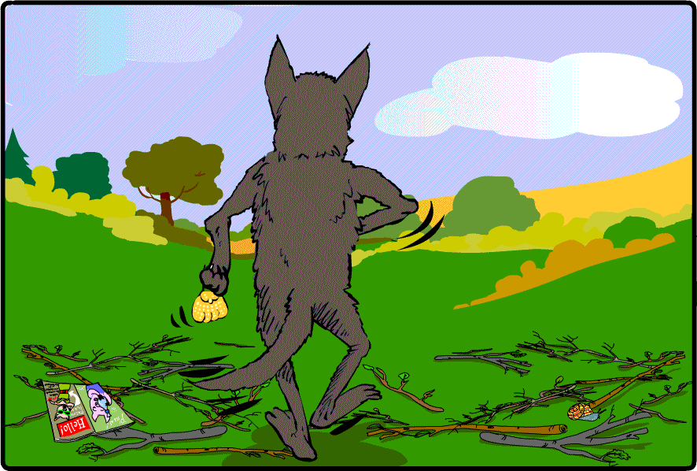

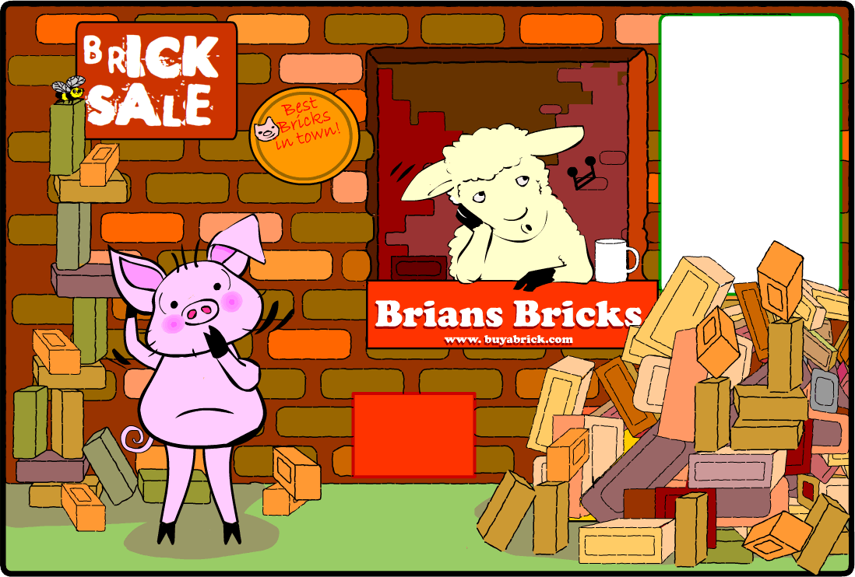
"What shall I build my house with?"
wondered Silly Pig.

SALE
TODAY

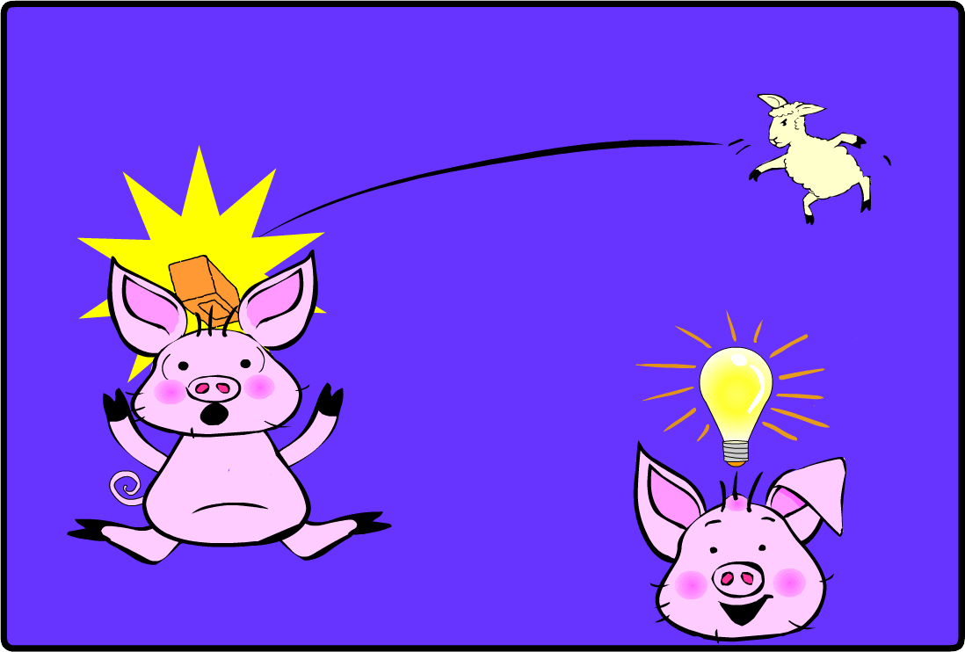



Oooooo.....bricks!
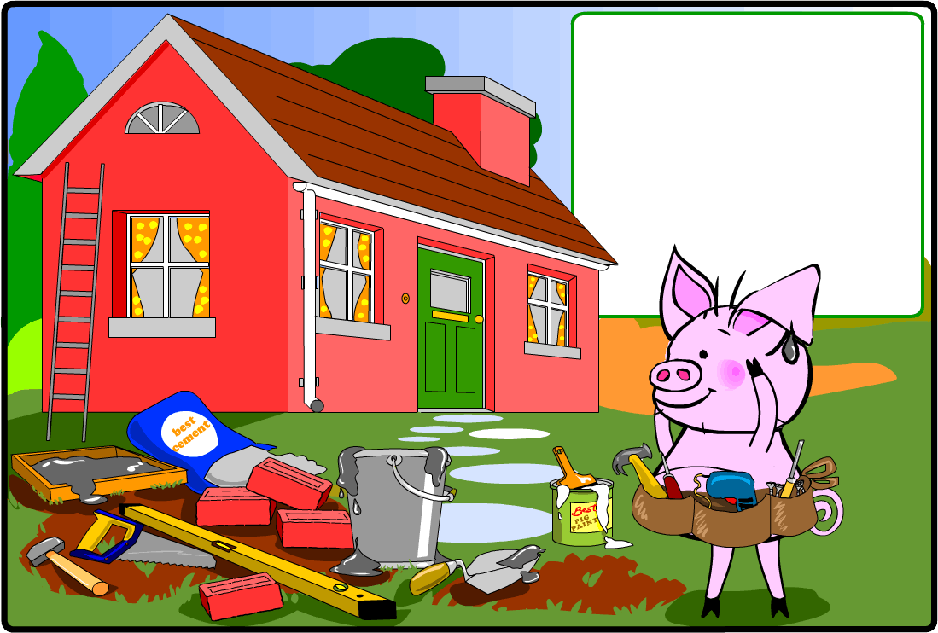
So Silly Pig built his house of bricks.
It was a fine, strong house. "Maybe I am not such a silly pig after all,” he thought.

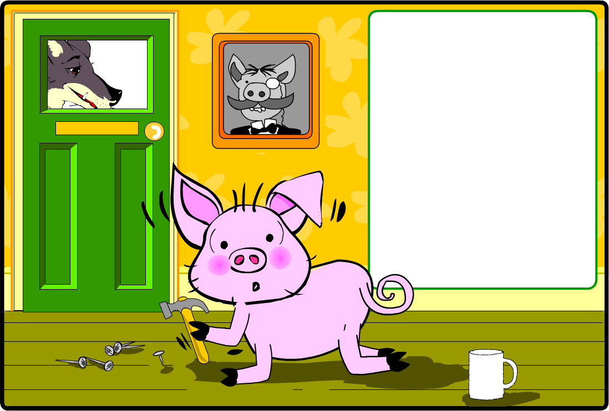
Along came the Big Bad Wolf.

He knocked on the door and said, "Little Pig, Little Pig, let me come in."

"Not by the hair on my chinny chin chin," said Silly Pig.

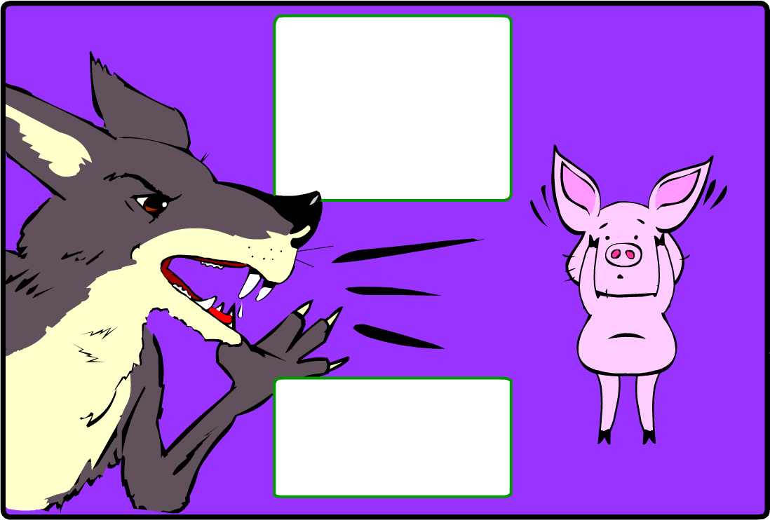
"Then I'll huff and I'll puff and I'll blow your house down!" shouted the Big Bad Wolf.

"Ooooh! I don't know what to do!" cried Silly Pig.

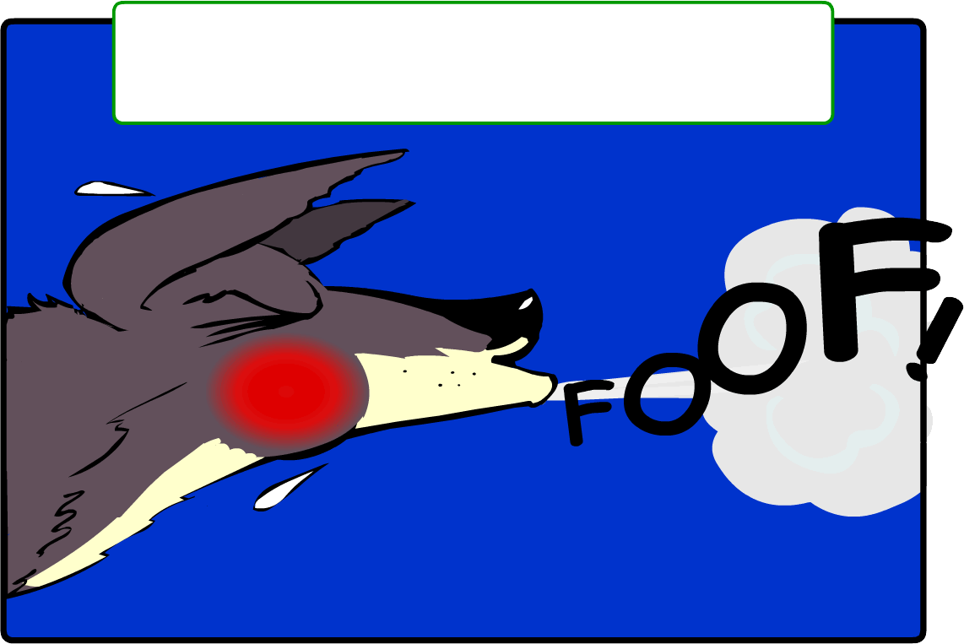
The wolf huffed and puffed and HUFFED and PUFFED and HUFFED and PUFFED.....

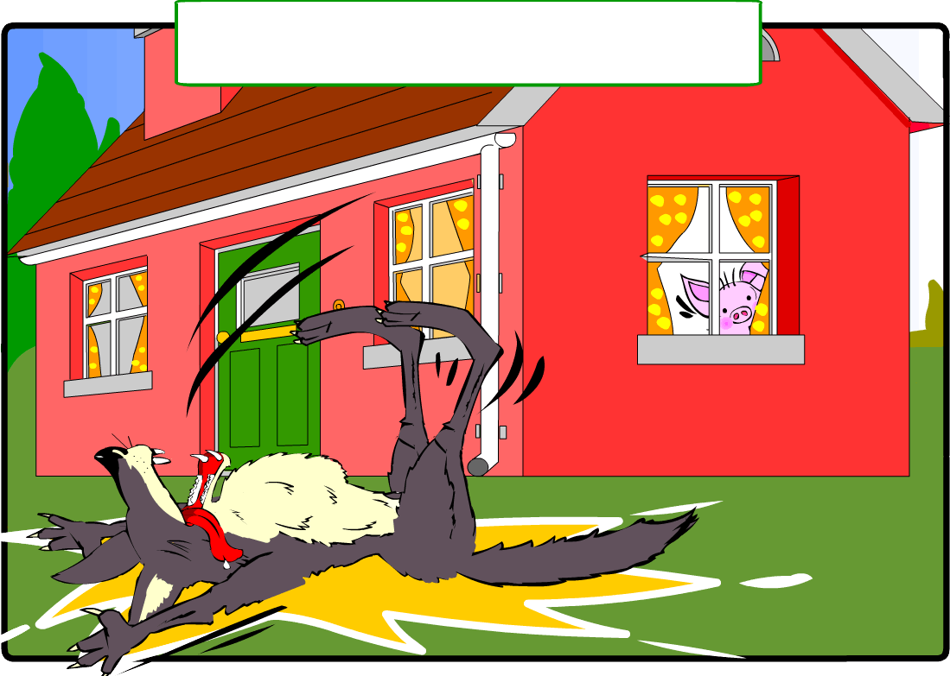
But the brick house did not move at all.

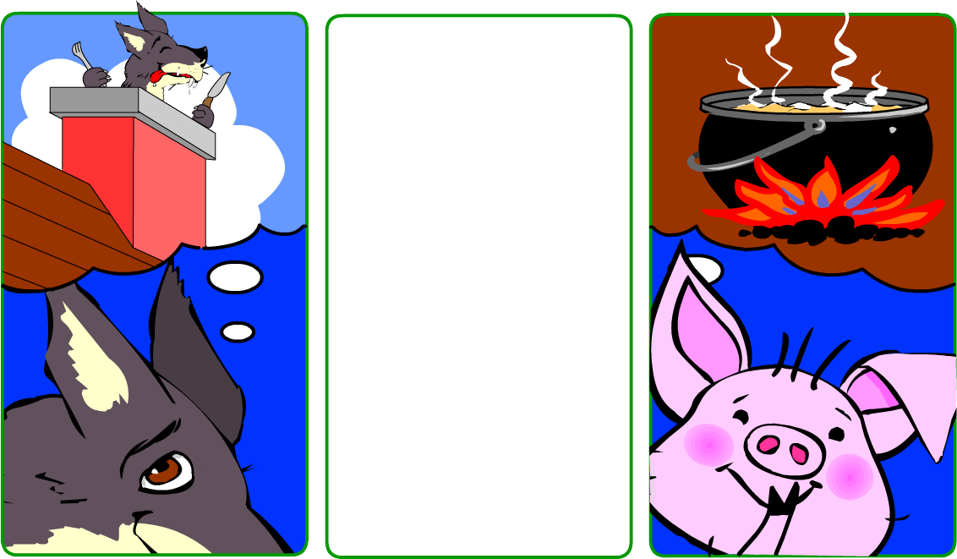
"I have a cunning plan,"
said the Wolf.
"I'll climb down the chimney and eat that
silly pig!"

”I have a cunning plan,” said Silly Pig. "I'll make a wonderful stew. I'll put the pot on the fire now."

(Don't forget that he
is still a bit silly!)

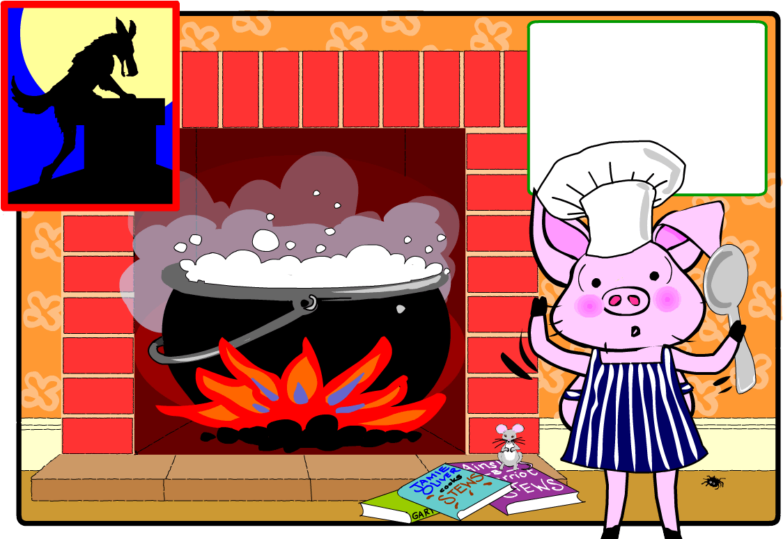
Heh! Heh!
"Oh!" cried Silly Pig. "What shall I put in my delicious stew?"

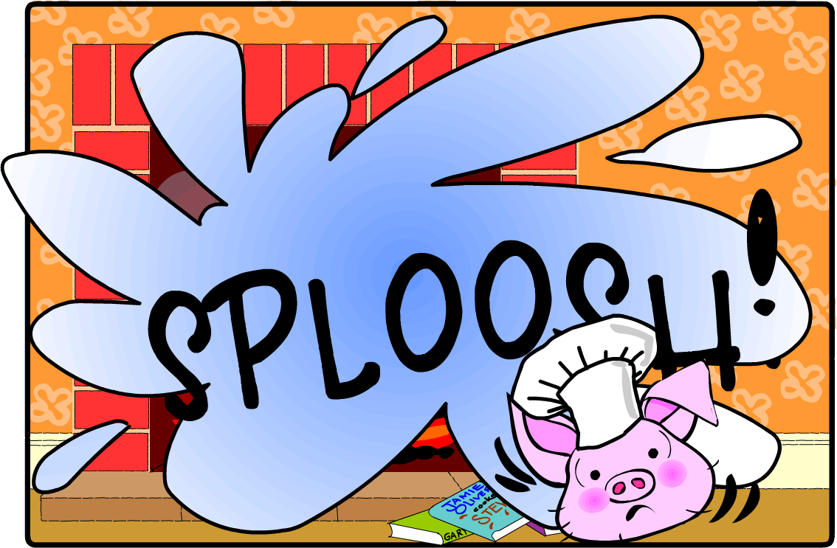

A Twist in the Tail

What happens next? Choose an ending from the three
below... or make up YOUR own ending!
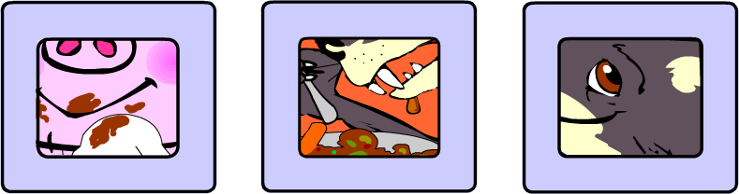

Turn one page
Turn two pages
Turn four pages

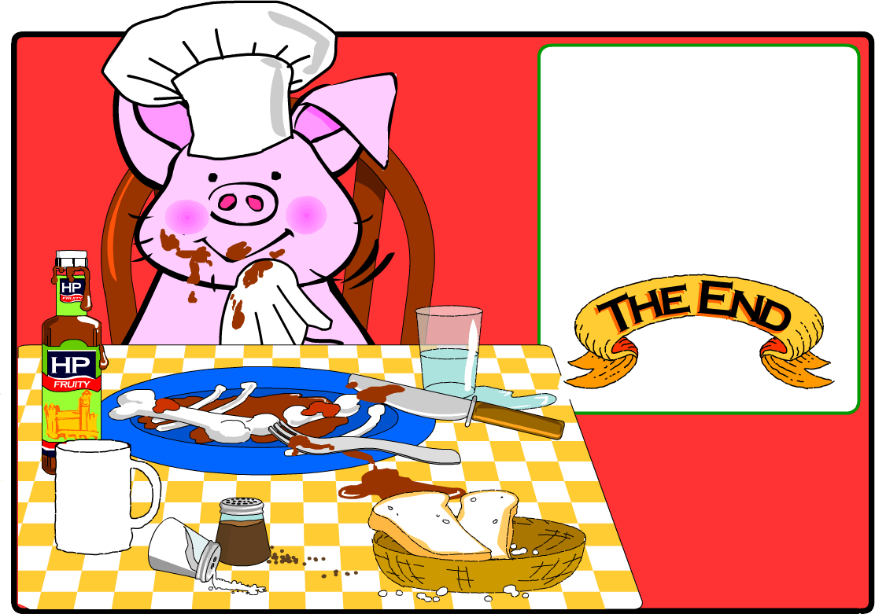
"That was lucky that the Big Bad Wolf dropped in to see me," thought Silly Pig,” because he made a very tasty stew!"

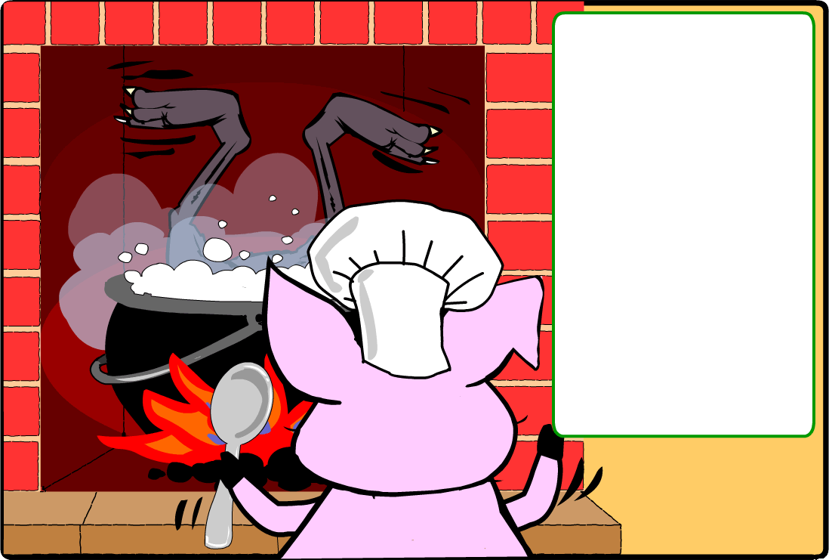
The wolf fell down the chimney and landed in the very hot water!

Silly Pig said, "Mr Wolf, I am making a vegetable stew and you must get out of it now! If you like, you can stay and try some."

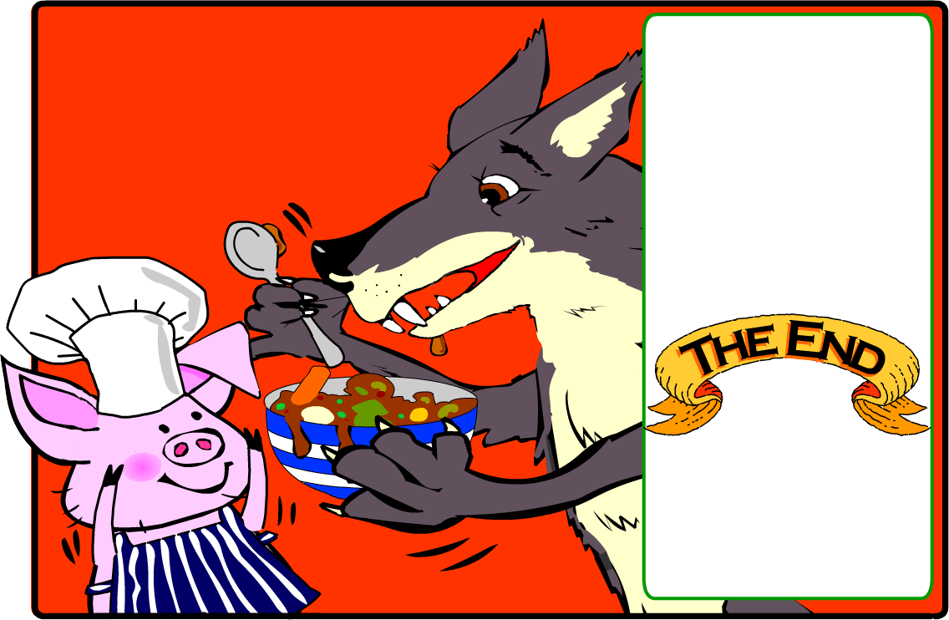
The Big Bad Wolf liked the stew.

"This is delicious," he said, "but there does seem to be a little something missing!"
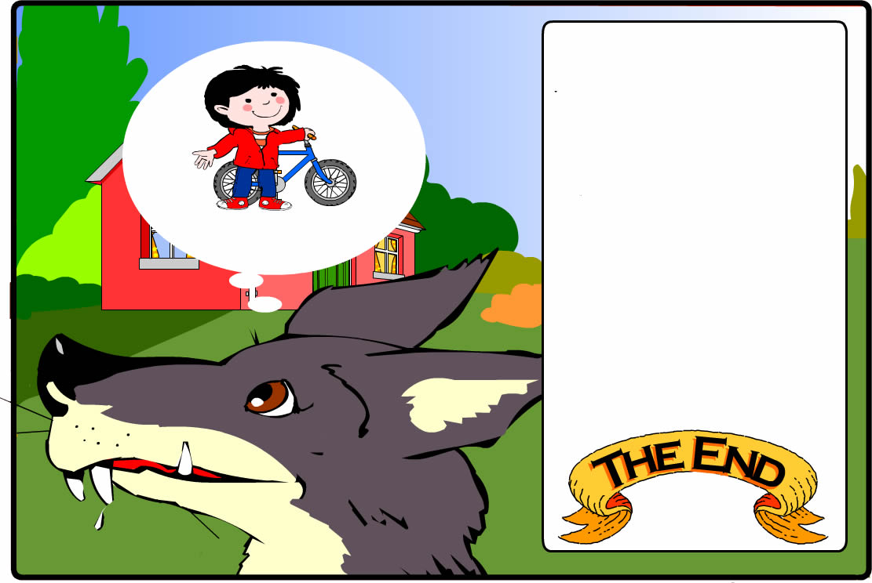
The Big Bad Wolf fell into the hot water!
He jumped out of the pot and ran out of the house.

"I won't go near that Silly Pig again," he panted. "Perhaps I'll go and see Little Red Riding Hood instead."

